BRACT’s

Vishwakarma Institute of Technology, Pune

Practical Implementation Sheet

Department: CSE-AI Semester: 5 Academic Year: 2026-27

Division: E Batch: 2 Practical No: 8

Roll no: 39 PRN No: 12414234 Name of Student: Rishi Gupta

Subject Name: Deep Learning

Problem Statement:
Implement Pretrained BERT Model for sentiment analysis or text classification on a sample dataset.

Algorithm:
- Import Libraries: Import PyTorch, NumPy, Pandas, Hugging Face Transformers, Datasets, and Scikit-learn for dataset handling, model training, and evaluation.
- Configure Device: Set the random seed and check GPU availability for faster model training.
- Load Dataset: Load the IMDB movie review dataset containing positive and negative sentiment labels. Select a smaller sample for experimentation.
- Analyze Dataset: Display the number of training and testing samples and check the distribution of sentiment classes.
- Load Pre-trained Model: Load the pre-trained BERT tokenizer and bert-base-uncased model using Hugging Face Transformers.
- Tokenize Text: Convert movie reviews into BERT-compatible token IDs, truncate long sequences, and apply dynamic padding.
- Configure Classification: Load BERT with a classification head containing two output neurons for negative and positive sentiment.
- Define Evaluation Metrics: Calculate accuracy, precision, recall, and F1-score to evaluate model performance.
- Train the Model: Fine-tune BERT on the IMDB training dataset using the AdamW optimizer and cross-entropy loss through the Hugging Face Trainer.
- Experiment with Epochs: Train separate models for one and two epochs and compare their evaluation metrics.
- Evaluate the Model: Generate predictions on the test dataset and display a classification report.
- Test Custom Sentences: Predict sentiment and confidence scores for new movie reviews created for experimentation.
- Save the Model: Save the fine-tuned BERT model and tokenizer for future use.

Code:
# Assignment 8: Pretrained BERT for Sentiment Analysis # Import libraries and install required packages
!pip -q install -U transformers datasets accelerate scikit-learn
import random import numpy as np import pandas as pd import torch
from datasets import load_dataset from transformers import (
AutoTokenizer, AutoModelForSequenceClassification, DataCollatorWithPadding,
Trainer, TrainingArguments
)
from sklearn.metrics import ( accuracy_score, precision_recall_fscore_support, classification_report
)

# Configure random seed and check computing device SEED = 42
random.seed(SEED) np.random.seed(SEED) torch.manual_seed(SEED)
print("Device:", "cuda" if torch.cuda.is_available() else "cpu")

# Load the IMDB dataset and select a smaller sample dataset = load_dataset("stanfordnlp/imdb") TRAIN_SIZE = 2000
TEST_SIZE = 500
train_ds = dataset["train"].shuffle( seed=SEED
).select(range(TRAIN_SIZE)) test_ds = dataset["test"].shuffle(
seed=SEED
).select(range(TEST_SIZE)) print("Training samples:", len(train_ds)) print("Testing samples:", len(test_ds))

# Analyze sentiment class distribution print("\nClass Distribution:")
print(
pd.Series( train_ds["label"]
).value_counts().sort_index()
)
print("\nExample Review:") print(train_ds[0]["text"][:300])
print("Label:", train_ds[0]["label"])
# Load the pretrained BERT tokenizer MODEL_NAME = "bert-base-uncased"
MAX_LENGTH = 256
tokenizer = AutoTokenizer.from_pretrained( MODEL_NAME

)
# Tokenize the movie reviews def toenize_function(examples):
return tokenizer( examples["text"], truncation=True, max_length=MAX_LENGTH
)
tokenized_train = train_ds.map( tokenize_function, batched=True
)
tokenized_test = test_ds.map( tokenize_function, batched=True
)
# Apply dynamic padding to the tokenized inputs data_collator = DataCollatorWithPadding(
tokenizer=tokenizer
)

# Configure the sentiment labels id2label = {
0: "NEGATIVE",
1: "POSITIVE"
}
label2id = { "NEGATIVE": 0,
"POSITIVE": 1
}
# Create a fresh pretrained BERT model for each experiment def create_model():
return AutoModelForSequenceClassification.from_pretrained( MODEL_NAME,
num_labels=2, id2label=id2label, label2id=label2id
)
# Define evaluation metrics
def compute_metrics(eval_pred): logits, labels = eval_pred

predictions = np.argmax( logits,
axis=-1
)
precision, recall, f1, _ = precision_recall_fscore_support( labels,
predictions, average="binary", zero_division=0
)
return {
"accuracy": accuracy_score( labels,
predictions
),
"precision": precision,

"recall": recall, "f1": f1
}

# Define a reusable training function def train_model(epochs, output_dir):
model = create_model() training_args = TrainingArguments(
output_dir=output_dir, num_train_epochs=epochs, per_device_train_batch_size=8, per_device_eval_batch_size=16, learning_rate=2e-5, weight_decay=0.01, eval_strategy="epoch", save_strategy="epoch", load_best_model_at_end=True, metric_for_best_model="f1", greater_is_better=True, logging_steps=50, report_to="none", fp16=torch.cuda.is_available(), seed=SEED
)
trainer = Trainer( model=model, args=training_args,
train_dataset=tokenized_train, eval_dataset=tokenized_test, processing_class=tokenizer, data_collator=data_collator, compute_metrics=compute_metrics
)
trainer.train()
metrics = trainer.evaluate() return trainer, metrics

# Experiment 1: Train BERT for one epoch trainer_1, metrics_1 = train_model(
epochs=1, output_dir="./bert_1_epoch"
)
# Experiment 2: Train BERT for two epochs trainer_2, metrics_2 = train_model(
epochs=2, output_dir="./bert_2_epochs"
)

# Compare the evaluation results comparison = pd.DataFrame({
"Metric": [ "Accuracy", "Precision", "Recall", "F1-Score"
],
"1 Epoch": [ metrics_1["eval_accuracy"], metrics_1["eval_precision"], metrics_1["eval_recall"], metrics_1["eval_f1"]
],

"2 Epochs": [ metrics_2["eval_accuracy"], metrics_2["eval_precision"], metrics_2["eval_recall"], metrics_2["eval_f1"]
]
})
print("\nExperiment Comparison:") print(comparison)
# Select the two-epoch model for final evaluation final_trainer = trainer_2

# Generate predictions and display classification report pred_output = final_trainer.predict(
tokenized_test
)
predictions = np.argmax( pred_output.predictions, axis=-1
)
print("\nClassification Report:") print(
classification_report( pred_output.label_ids, predictions, target_names=[
"NEGATIVE", "POSITIVE"
],
digits=4
)
)
# Define a function to predict sentiment for new sentences def predict_sentiment(texts):
final_trainer.model.eval() inputs = tokenizer(
texts, return_tensors="pt", padding=True, truncation=True,
max_length=MAX_LENGTH
)
inputs = {
k: v.to(final_trainer.model.device) for k, v in inputs.items()
}
with torch.no_grad():
outputs = final_trainer.model(
**inputs
)
probabilities = torch.softmax( outputs.logits,
dim=-1
)
predictions = torch.argmax( probabilities,
dim=-1
)
for text, pred, probs in zip( texts,

predictions, probabilities
):
print("\nText:", text) print(
"Sentiment:", id2label[pred.item()]
)
print(
f"Confidence: {probs[pred].item():.2%}"
)

# Test the model on custom movie reviews sample_texts = [
"The movie was amazing and the acting was excellent.", "The story was boring and the movie was disappointing.", "The visuals were great but the plot was weak."
]
predict_sentiment(sample_texts)
# Save the fine-tuned model and tokenizer SAVE_PATH = "./bert_sentiment_model"

final_trainer.save_model( SAVE_PATH
)
tokenizer.save_pretrained( SAVE_PATH
)
print("\nModel saved to:", SAVE_PATH)

Output:
- Loading and sampling the IMDB dataset with class distribution analysis.
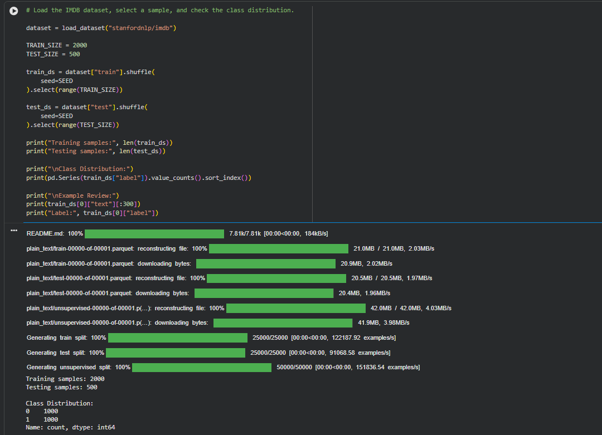

- Tokenizing movie reviews and configuring the pretrained BERT model.
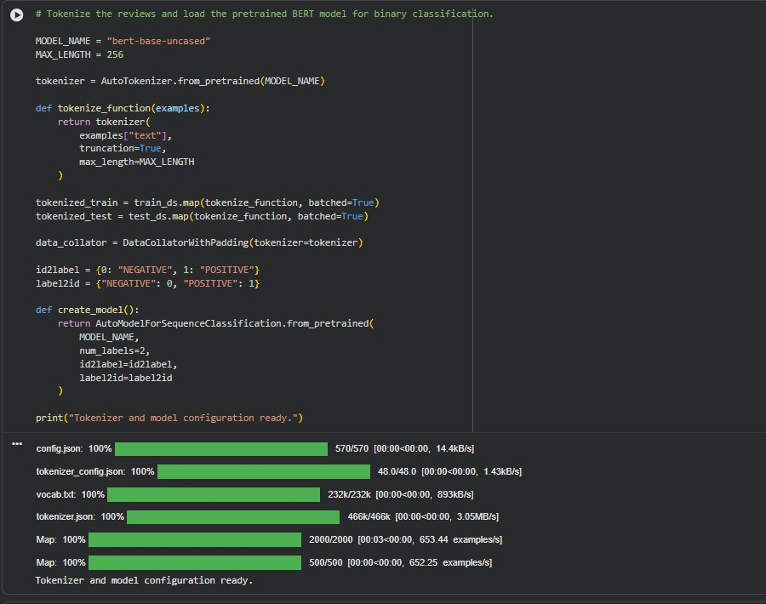

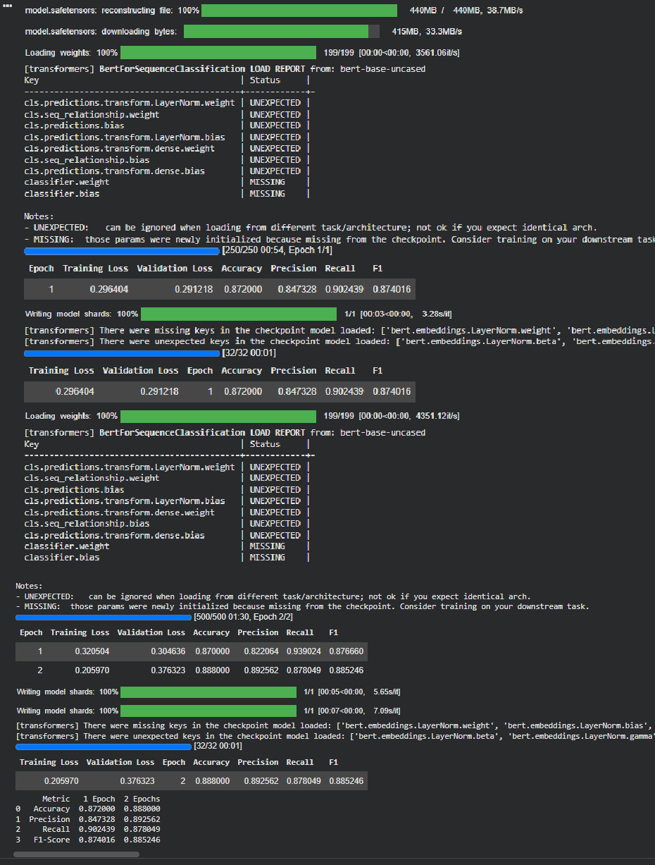
- Fine-tuning BERT for sentiment classification and displaying training evaluation metrics.

- Evaluating the trained BERT model and predicting sentiment for custom movie reviews.
